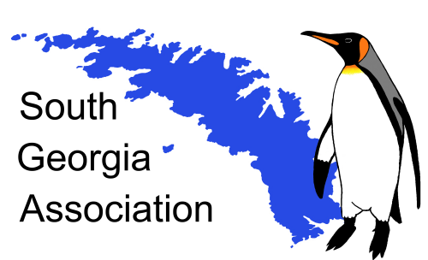 **Initiative fund**

The Association has an Initiative Fund. Applications are welcomed from all who have an interest in South Georgia and who wish to initiate or support projects that will stimulate awareness of, and interest in, South Georgia and the South Sandwich Islands. Grants will be awarded up to a maximum of £1,000 and successful applicants would be expected to become members of the Association. Potential applicants should contact Dr Bill Block, British Antarctic Survey, High Cross, Madingley Road, Cambridge CB3 0ET ([wcb@bas.ac.uk](mailto:wcb@bas.ac.uk)) to discuss their proposals. There are no closing dates for applications, which may be submitted at any time.

Recent awards from the Initiative Fund have included the following:

### 2021: Seabird By-Catch Outreach Project in Japan - RSPB/Birdlife project to raise awareness in Japan of the by-catch mortality of South Georgia’s seabirds in tuna fisheries.

2018-19: An archaeological project investigating the history of sealing at selected sites on South Georgia by a team from the Cambridge Archaeological Unit aided by citizen scientists.

## 2017-18: Participation in Homeward Bound Expedition

[Funding support for Miss Madeleine Brasier](http://southgeorgiaassociation.org/sga-legacy/initiative-award-2017-1.php) to enable her to participate in an all-female leadership training expedition to the Antarctic as part of [Homeward Bound](https://homewardboundprojects.com.au/).

2011-2013: Oral History Project

This is a project to record memories of those who worked in South Georgia and elsewhere in the Antarctic. Funding was provided to record interviews with three scientists who undertook research on South Georgia.

2011: Habitat Restoration Project

A contribution was made to the South Georgia Heritage Trust's project to eradicate alien species - rats and reindeer - from the island, restoring the habitat for native species such as ground-nesting birds.

2010: Dictionary of the Falkland Islands

SGA donated copies of David Tatham's *Dictionary of the Falkland Islands* to various libraries with interests in South Georgia.

2010: History of Duncan Carse's South Georgia Surveys

SGA provided support to Alec Trendall during publication of his book *Putting South Georgia on the Map* and donated copies to various institutes and national libraries.

2009-2010: Digitisation of photographs

SGA funded the digitisation of David Ferguson's photographs of South Georgia from 1912, and Harrison-Matthews cine film *Hay film from Prince Olav*.

2006-2007: Historic sites survey

Funding was given for a field survey of a number of historic sites on the island.

2006: Antarctic Magistrate

A contribution was made towards the publication costs of *Antarctic Magistrate: the Life of Edward Beveridge Binnie*.