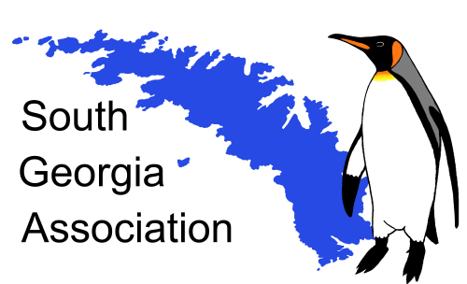

South Georgia Association
Scott Polar Research Institute
Lensfield Road
Cambridge CB1 2ER U.K.
www.southgeorgiaassociation.org

Press Release

The Morag Husband Campbell Medal

South Georgia Association

2024 Award to Ian Brett Hart

The South Georgia Association is delighted to announce the award for the seventh year of the Morag Husband Campbell medal for 2024 to Ian Hart, “For his significant contributions to the history, heritage and knowledge of South Georgia.”

The Medal has been made possible by a generous bequest from a long-standing supporter of the Association, Miss Morag Husband Campbell. She was so enthralled when visiting South Georgia, she determined to leave a bequest to the SGA. The Medal comprises a Sterling silver relief medallion, 60mm in diameter. The name of the awardee is inscribed on the reverse.

The Recipient
Ian Hart is the leading historian of the Southern whaling industry which played a fundamental part in the history of the settlement of South Georgia and its economy. He assisted Nigel Bonner in establishing the South Georgia Whaling Museum at Grytviken in the early 1990s. Ian Hart undertook the first curatorial work creating a ledger for recording the artefacts and items for the emergent Museum in Grytviken from 1992 to 1995.
He has devoted many years of study in Britain and Norway tracing the development of the whaling industry from its pioneering days to its eventual decline and withdrawal from the Island in 1965. In addition to numerous articles, he has written a series of detailed and authoritative works on aspects of South Georgia’s history. These include:

2001/03/21 PESCA: The History of the Compañia Argentina de Pesca Sociedad Anónima of Buenos Aires. An Account of the Pioneer Modern Whaling Company in the Antarctic. [pub. Aidan Ellis: Revised edition 2003] & [Pequena: 2021. New extended edition of 675 pages]
2006 Whaling in the Falkland Islands Dependencies 1904-1931. A History of Shore and Bay-based Whaling in the Antarctic. [pub. Pequena]
2009 Antarctic Magistrate: A life through the lens of a Camera. (The life of Edward Beveridge Binnie). [pub. Pequena]
2014 VIOLA: From the Great War to Grytviken. The Life and Times of a Hull Steam Trawler. (Co-author with Robb Robinson). [pub. Lodestar Books]
Furthermore, he has written several other books in regard to whaling in and around Antarctica:
2014 A história da caça de baleias no Brasil: De peixe real a iguaria japonesa. (Co-author with William Edmundson). [pub. DISAL Editora, São Paulo, Brazil].
2016 Whale Factory Ships and Modern Whaling 1881-2016. [pub. Ships in Focus Publications]
2017 A History of Whaling in Brazil – From royal fish to Japanese delicacy. (Co-author with W. Edmundson). [pub. Pequena]
2020 Austral Enterprises – A History of shore, bay-based and pelagic whaling and sealing in the Southern Ocean encompassing The Southern Whaling & Sealing Company, The Kerguelen Sealing & Whaling Company and their associated enterprises at South Georgia, the Antarctic peninsula, the South Indian Ocean and South Africa. [pub. Pequena]

He was a contributor of 23 entries to The Dictionary of Falklands Biography (including South Georgia). From Discovery up to 1981. [edited by David Tatham] [Revised on-line with additional contributions https://falklandsbiographies.org to 2021]

The Award will be presented to Ian Hart at the next meeting of the Association in July 2024.

For Further Information: Fran Prince (secretary@southgeorgiaassociation.org)
Website: www.southgeorgiaassociation.org



Ian Hart

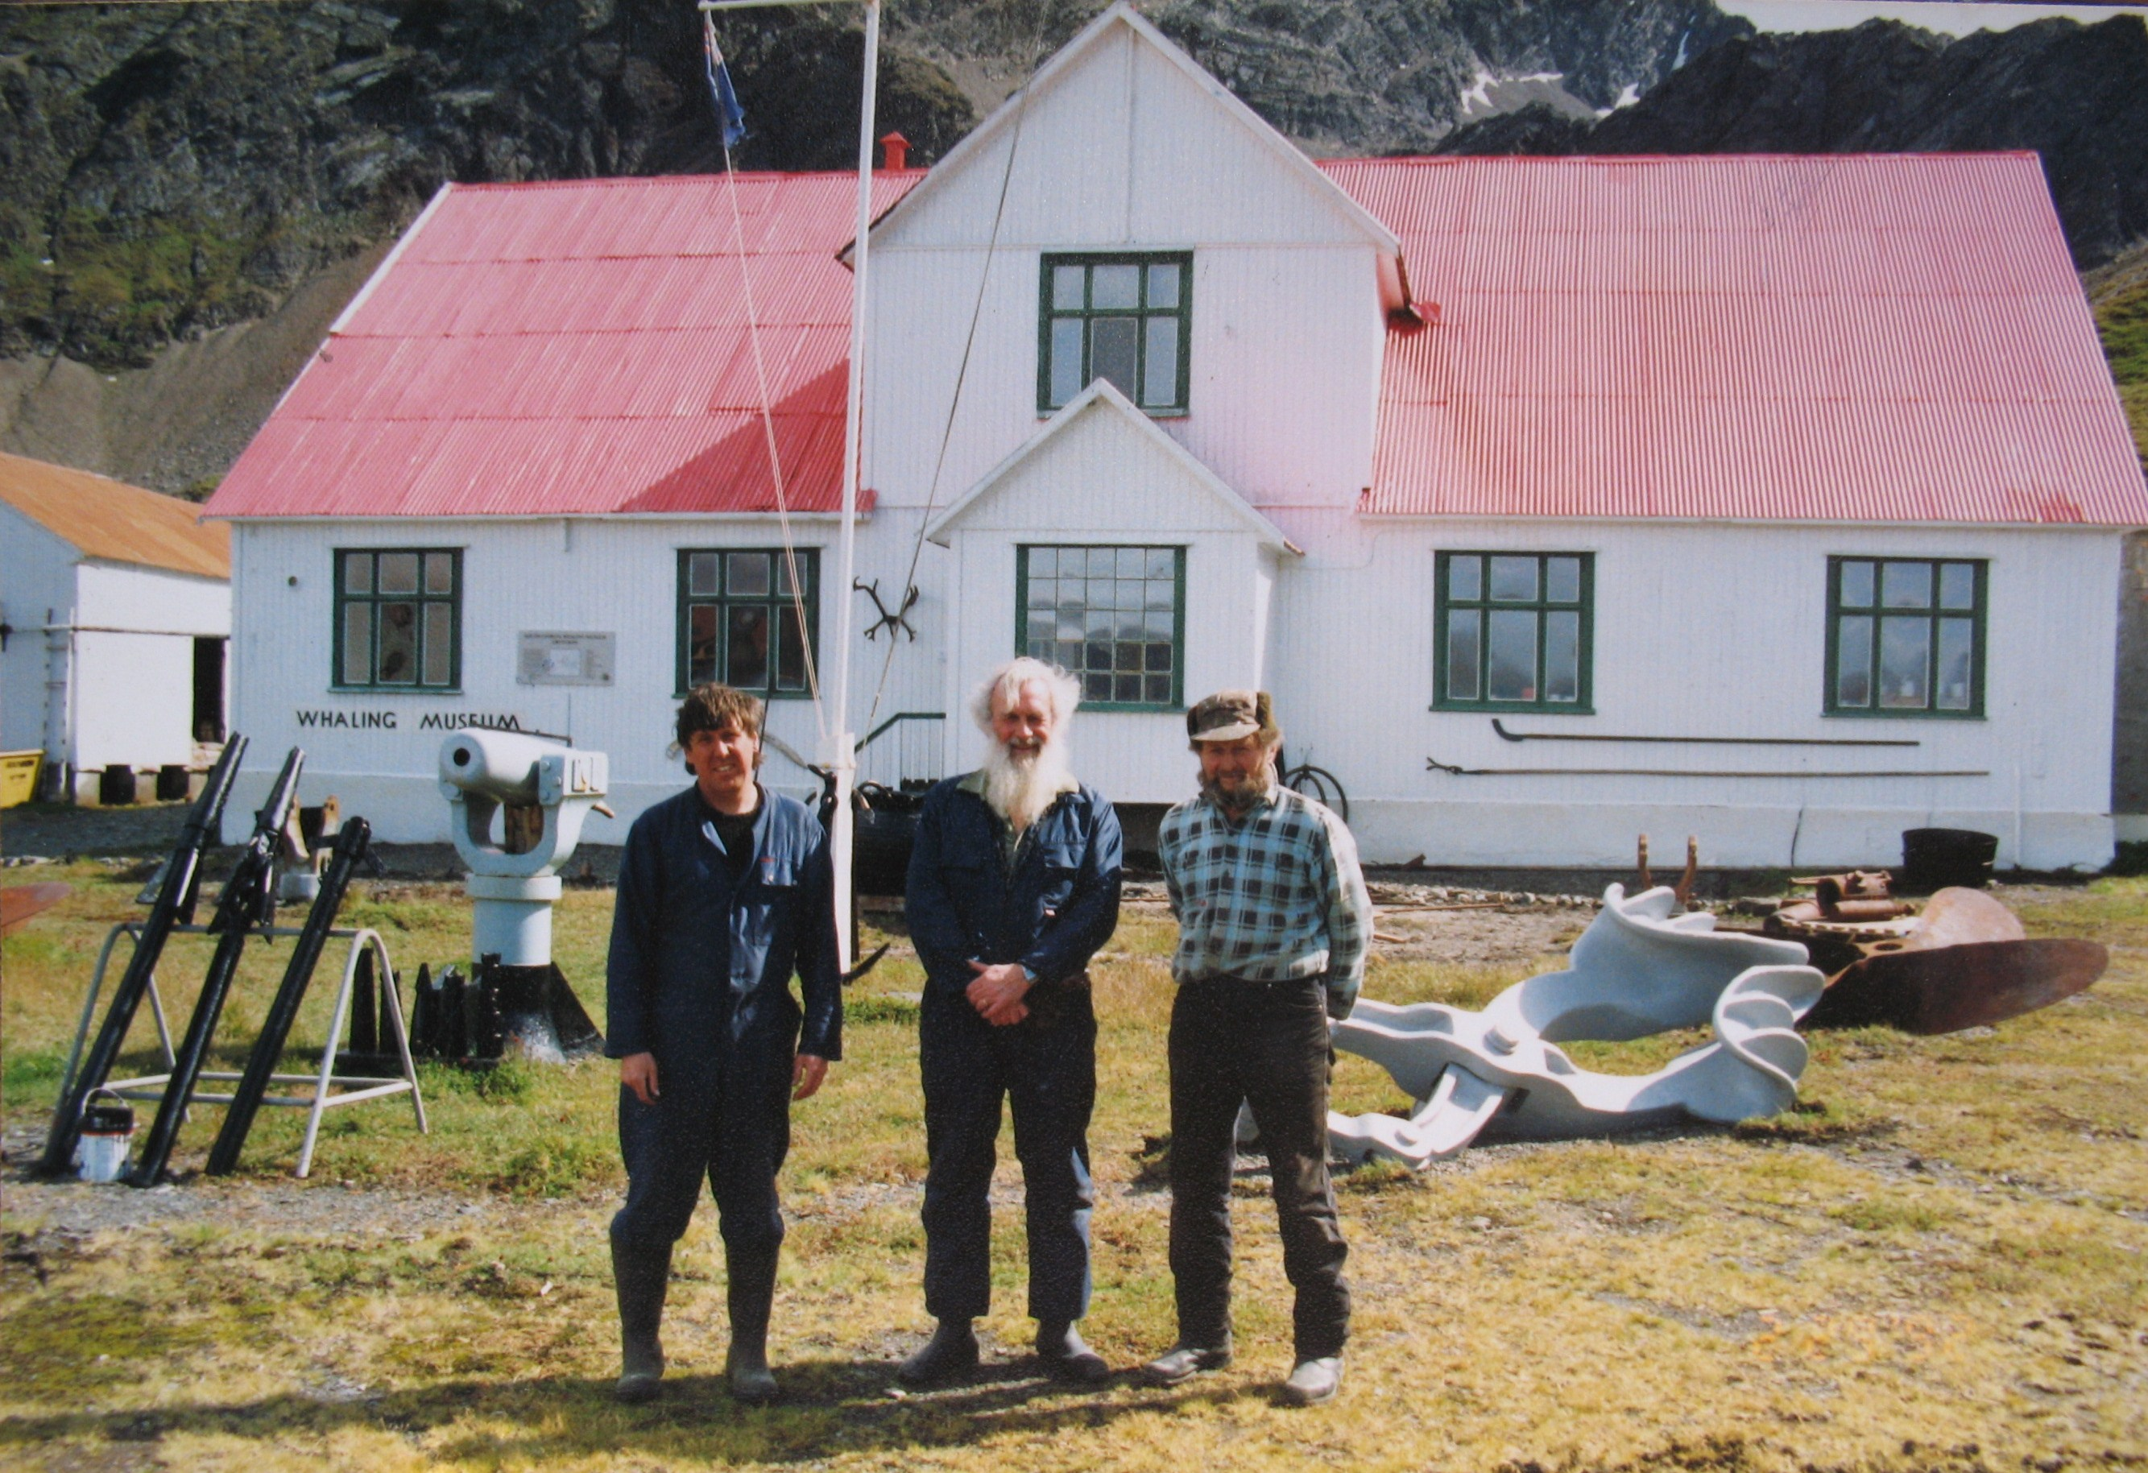

The Grytviken Museum Team 1993

From the left: Ian Hart, Nigel Bonner, Bob Kluzniak

Notes for Editors:

The Award: is to individuals who have contributed significantly to the understanding, appreciation and promotion of South Georgia. This includes i) scientific studies as well as the arts and humanities including culture, history, heritage, artistic endeavour etc. ii) adventurous travel and "exploration", iii) activities which enhance the wider appreciation of South Georgia (e.g. in the media or through administrative functions).

South Georgia: is a sub-Antarctic island and a British Overseas Territory in the southern Atlantic Ocean. It is remote, mountainous and of exceptional natural beauty, with abundant wildlife both on the island and in the surrounding ocean. Uninhabited apart from two small research stations and a few government employees, it is an unspoilt wilderness with a fascinating heritage that is none the less environmentally vulnerable and has been featured in the recent Blue Planet II series. It is 165 km long and some 35-km wide. The Falkland Islands are about 1,300 km (810 mi) west. Captain James Cook made the first landing in 1775. It was the base for the extensive harvesting of fur and elephant seals in the late 18th and 19th Centuries. From 1904 to the 1960s its primary activity was whaling. Sir Ernest Shackleton landed and traversed the island after his perilous crossing from Elephant Island in 1916. He died on a subsequent expedition and is buried at the whaling station of Grytviken.

The South Georgia Association: was formed in 2001 to give voice to those who care for South Georgia and has several hundred members. Its aims are to encourage interest in, and concern for, the island of South Georgia, to encourage the study of South Georgia, and promote the conservation of its natural and cultural heritage, and to promote contacts and encourage fellowship among those who have lived and worked in or around South Georgia, have visited or are interested in the Island. Further details are to be found at: http://www.southgeorgiaassociation.org

