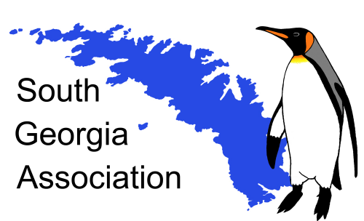
Morag Husband Campbell Medal
South Georgia Association

The South Georgia Association is inviting nominations for the award of the Morag Husband Campbell medal for the sixth year.

The Medal has been made possible by a generous bequest from a long-standing and enthusiastic supporter of the Association, Miss Morag Husband Campbell. It comprises a Sterling silver relief medallion, 60mm in diameter. The name of the recipient and the year will be inscribed on the reverse. It is intended to award the Medal every year or every other year depending upon nominations.

The Association has agreed that the Medal should be awarded to individuals who have contributed significantly to the understanding, appreciation and promotion of South Georgia. This would encompass i) scientific studies as well as in the arts and humanities including culture, history, heritage, artistic endeavour etc., ii) adventurous travel and "exploration", iii) activities which enhance the wider appreciation of South Georgia (e.g. in the media or through administrative functions).

Nominations (self-nominations are not permitted) should be made on an official Nomination Form available on the website and from the Secretary of the Association to whom they should be sent no later than 28th February 2023. The award would be made at the Annual General Meeting of the Association. Given present uncertainties regarding Covid-19 in the UK the AGM may be either delayed or conducted by video streaming.

Professor David J Drewry
Chair SGA

